UNIVERSITY OF RWANDA

|  |
| --- |
| Close-up image showing the leaf-sides of two oversized books side-by-side on a bookshelf, with additional books in soft focus background |
| **CFYPAS (CSE FINAL YEAR PROJECT ARCHIVING SYSTEM)**  TECHINICAL REPORT |
| |  |  |  | | --- | --- | --- | | LECTURER: ERIC HITIMANA | 12/10/22 |  | |

COLLAGE OF SCIENCE AND TECHNOLOGY

DEPARTMENT: COMPUTER and SOFTWARE ENGINEERING

MODULE : SOFTWARE SEDGIN AND DEVELOPMENT LAB

YEAR OF STUDY: YEAR3.

GROUP MEMBERS

|  |  |  |
| --- | --- | --- |
| NO | NAMES | REG NO |
| 1 | Elissa MUNANIRA | 220011143 |
| 2 | Henriette HABWIKUZO | 220003641 |

**Contents**

**CHAPTER1: INTRODUCTION 2**

**1.1Historical background of the case study 2**

**Problem statement 3**

**Objectives of our project 4**

**CHAPTER2 : SYSTEM ANALYSIS AND DESIGN 4**

**System analysis 5**

**Functional Requirements of project 5**

**SYSTEM DESIGN 7**

**DATA BASE DESIGN WITH ERD AND RELATIONSHIP 8**

**CHAPTER3: IMPLIMANTATION 10**

**INTRODUCTION OF THE SECTION 10**

**ABOUT THE CFYAS 10**

**FEATURES 10**

**MANAGEMENT SIDE 10**

**PUBLIC SIDE 11**

**SYSTEM SNAPSHOTS OF SOME FEATUES 11**

**Public Home page (landing page) 11**

**About us page 12**

**Contact page 13**

**CHAPTER4. CONCLUSION AND RECOMMENDATION 29**

**CONCLUSION 29**

**RECOMMENDATION 29**

**APPENDIX : GitHub link 29**

# CHAPTER1: INTRODUCTION

## 1.1Historical background of the case study

CFYPAS is a system that store and manage CSE final year student’s projects in one system. Manual based system also one of the human activity systems that are create for are specific purpose. But in the upcoming times, the way data and information is handle will be change based on the technology implement. The way of human thinking will create the new ideas to manage the information with the proper system. Then, there come with an idea to manage the information with the computerize system and arrange the data in one centralize database system. CFYPAS is develop to solve the problem occur in the manual-based system on the university of Rwanda college of science and technology.

Each project that has been done by CSE final year students do not have a proper place to store it effectively. The project report is stored by using manual method such as rack book record and for the softcopy is burned on Compact Disk (CD).

This method is not too effective to apply without the combination with computerize database. Besides, CFYPAS can be used to manage the information about students’ projects with more efficient. The method of implementation can solve the problem occurs on the cse department. Each student or staffs need to take a long time to find the related project they wanted in the libraries. Proper information about projects has been done by CSE final year students it easier to find if there is more systematic system that can store all the projects in one system.

According to O’Brien, J., and Marakas, G. on the book they write titled Management Information Systems, Computer Software (2008) (page185). They said operational database stores information about the activities of an organization” and this significantly was showing the archive system like CFYPAS can be used to stores all related project create by CSE students in a University of Rwanda. In addition, CFYPAS’s web technology involves the markup language with the help of bootstrap and multimedia packages where PHP is used as a programming language that generates Laravel framework.

Firstly, the project must finish by students and was by supervised by, coordinator and supervisor. Then, CFYPAS is used to store the projects information and make sure the projects will not lose their information.

The useful of this system is could help junior students to find the past year student project or research and made as reference or new idea. But they must get the permission with the supervisor whether the report can be downloading or not. In manual system, each student could hard to get information regarding the project they are wanted. With this system architecture, it can help the student get the information in a proper way.

## Problem statement

Nowadays, each human task needs information to make sure it can do in the proper ways. The technology rise was improved on how human get the accurate information. However, there some organization still implements manual arrangement system and it cause some problems in present and future use. The manual system makes the searching of documents became harder. It is hard to make decision whether the information gathering is achieved or not. If their errors occur or need to update on the documents, it is often necessary to recreate the whole documents from beginning, rather than just update a current version with the related detail by using system. At University of Rwanda, final year student project is stored in different libraries.

The hard copy of the project is arranged in the book rack without a proper arrangement of category: owner, supervisor, type of project like IOT or web-based project. The soft-copy of the project that burned into compact disk (CD) also stored at libraries. The manual arrangement could lead year3, year2 and year1 students hard to find the project they are wanted.

Human error also can cause the arrangement of project could change in wrong place. By the time, it hard to find the project because there are lacks of information put at the side cover of project and also to the CD.

The time constraint faced by students also lead the information about project their wanted is hard to get. Most student still assignation with their time goes to libraries. Some of students still do not know where the libraries are.

After the lecturer session, most of student will prefer to take a rest with their time. In addition, if they are wanted to find the information at the day-night, it can cause a lot of problem because the libraries already closed. The distance of the libraries with their hostel also is one of the causes that lead students lack arrive to the room.

In conclusion, students do not have much time to go to libraries continuously.

Move to the safety of the projects, the safety of the whole project is not guaranty at all. Firstly, the project arranged at the room can still damage or loss that cause by human error. It is hard to retrieve back the project like an original one. All the projects also have another copy in Compact Disk (CD), but it also not has a safety guaranty to make sure the integrity of the data inside. The CD can also damage or stolen by unscrupulous people. It is important to have awareness about the integrity of project to make sure it can usable as a reference for future students.

## **Objectives of our project**

In generally, the objective of this project is to develop an archive system that can solve any related problem occur. The objectives of the project are described as below:

*To identify the requirements which are useful to develop an archive system that can help faculty to store the final year CSE student’s project in one system and make sure it easy to keep track.

*To design a system that can solve the most of student's time constraint and distance by help them to find references using online method.

*To develop a system that can maintain the safety of the project and avoid any physical damage

*To help the administrator and supervisor to manage past final year projects thesis for the students of computer and software engineering (CSE) as well as assist students to generate ideas and make decision by choosing the best topics for their current final year projects based on what research area, they are interested in. Hence,

*To classify projects regarding the related field research area such as web-based projects, internet of thing (IoT)-based projects and others. Moreover, the system could filter and give the recommendations of the research or projects based on the keywords. With all these features, it is more convenient for the students and lecturers (supervisors) to search and manage the final year projects thesis.

# **CHAPTER2 : SYSTEM ANALYSIS AND DESIGN**

## System analysis

### Functional Requirements of project

#### Student and other final users

The students are the main focused final user of the CFYPAS, where the students have the capacity of searching the previous uploaded projects where they are going to get the project title, abstract of it. But if he/she wants to view or download the full project, he must have an account there for logging in and get more details of the project because if he or she login, he should get the full access of viewing all about the searched project and even downloading the PDF version as it is uploaded. But are only student, the other user who is interested can search and get the support from the project.

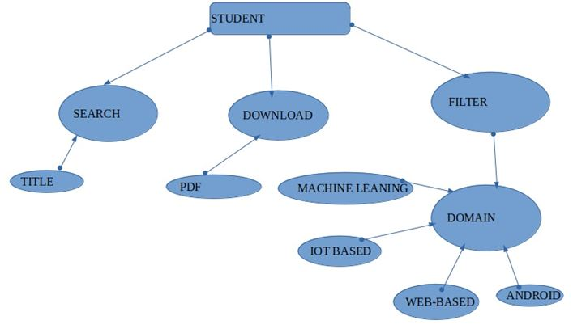

#### Lectures (supervisors)

The lectures (supervisors) are other user who is allowed to add a new final year project thesis of the students and he/ she also can retrieve the submitted thesis and view them or downloading it for a given purpose like updating their curriculum vitae (CV) or giving ideas to their current supervisees about what they can do in order to improve their research.

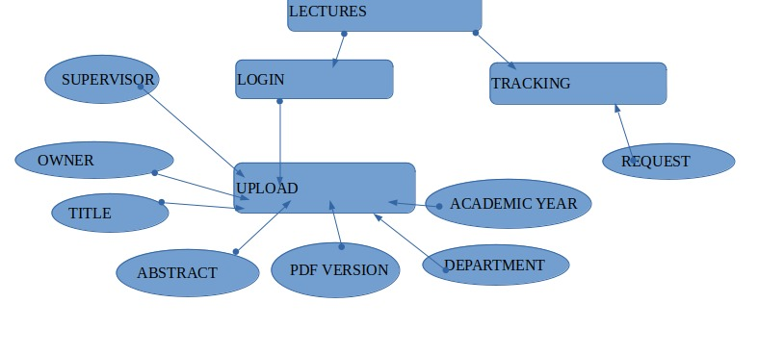

#### Administrator

Administrator of the system should be the selected lecture/ HOD of the department of computer and software engineering (CSE). He/she is in charge of giving the authority to the other lecturers to get access to the system and remove the unneeded users (the lecturers who are not still in charge of supervising). He also has the capacity of adding new final year projects into the system with the title, owner, phone’s own, abstract, year, supervisor, department and field that the student has been dealt with. As the administrator, should have the capacity of updating the system regarding what new he/she wants to improve the convenience of the system.

As with other web systems, the admin should have the dashboard where he/she is going to take control over the whole system. In order to do that, the administrator should first login as admin and get the dashboard to manage both students and lecturers and perform other related work.

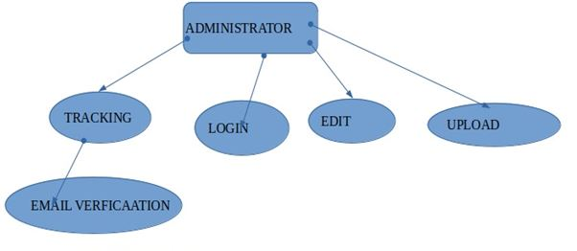

## SYSTEM DESIGN

UI design (sketch of the UI module)



1. Email verification

2. Accept/reject

3. Request

4. Accept/reject message

5. Project name

## **DATA BASE DESIGN WITH ERD AND RELATIONSHIP**

The following is how the database tables are related, there are many tables that are used and are shown here as follow with the relationship

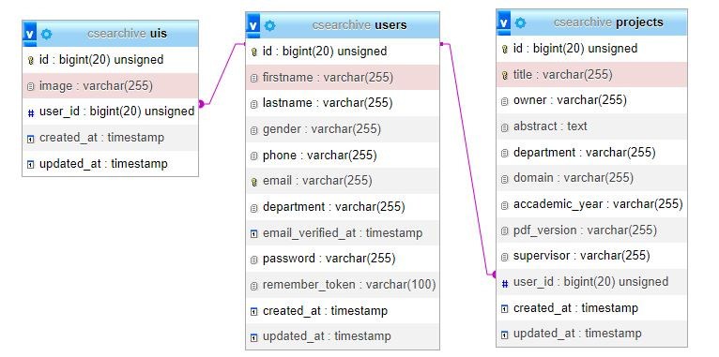

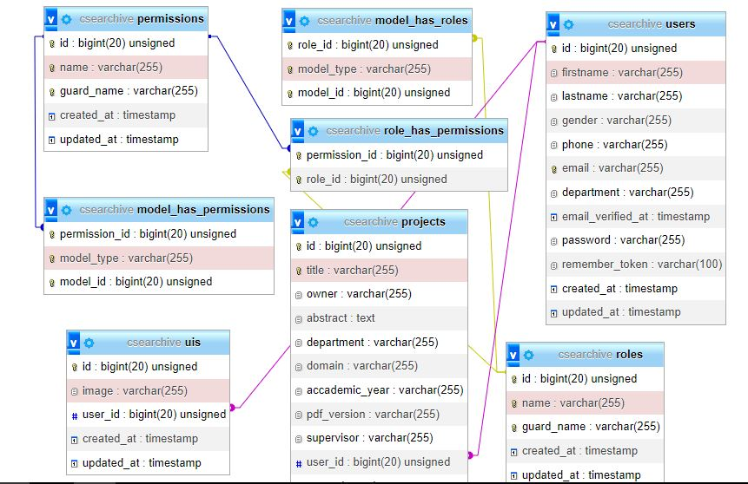

# CHAPTER3: IMPLIMANTATION

## INTRODUCTION OF THE SECTION

This section will include all about the CFYAS, features with the screenshot as visitor can interact with our CFYAPS.

The following is how the project look at the final users. In this part is where the use of project is shown by the user on interface.

## ABOUT THE CFYAS

We developed this project using the following:

* XAMPP V3.3.0 as our local webserver that has a PHP Version 8.0.7
* PHP language
* HTML
* CSS
* JavaScript
* Bootstrap
* AdminLTE
* And some other plugnins/libraries.

## FEATURES

### MANAGEMENT SIDE

* Secure login and logout
* Dashboard
* Manage archives

1.list all project submitted by the students

2.view the project details

3.publish the project to the public

4.unpublish project to the public

* Manage system information

### PUBLIC SIDE

* Secure login and registration
* Home Page (displays the website’s Welcome message)
* Submit projects
* Project list (list all published Projects, list all Published projects per type like IOT or web)
* Profile (Display the Student system information, list submitted projects)
* Search project

### SYSTEM SNAPSHOTS OF SOME FEATUES

### Public Home page (landing page)

This part show what the one who will search for our project should see as landing page

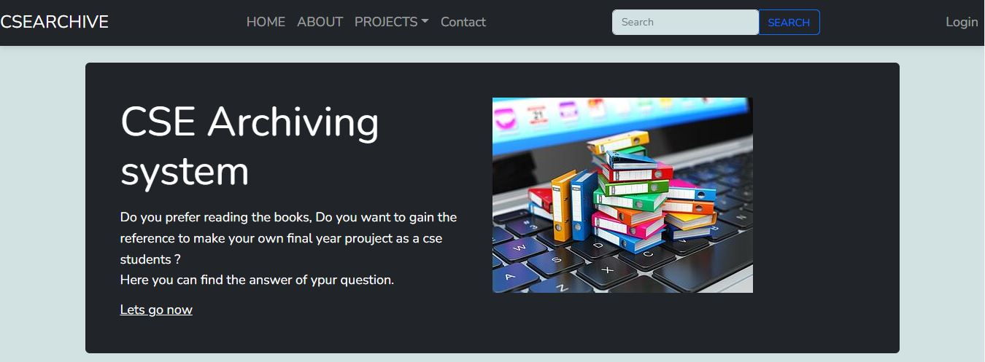

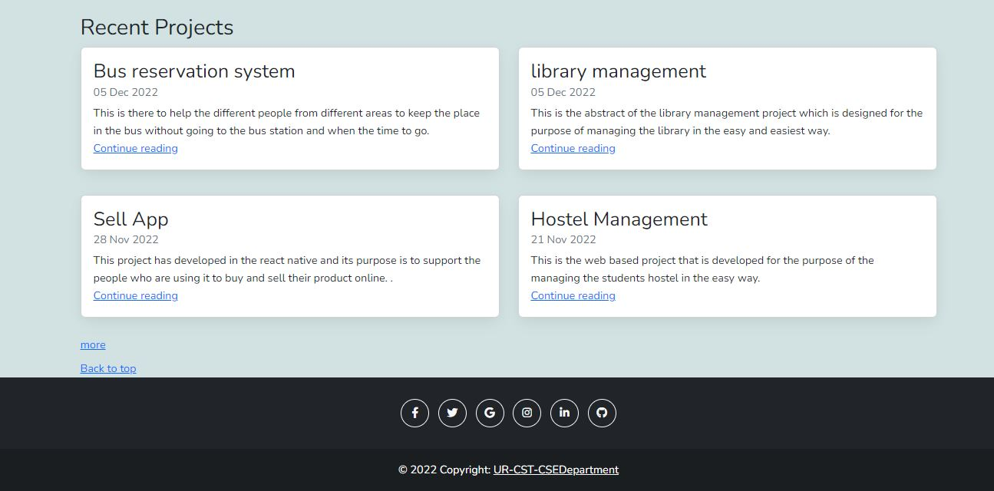

### About us page

On this page the researcher should get few information about us and get the contact us form if he/she is interested to talk to us, he/she can do so by sending message to that form.

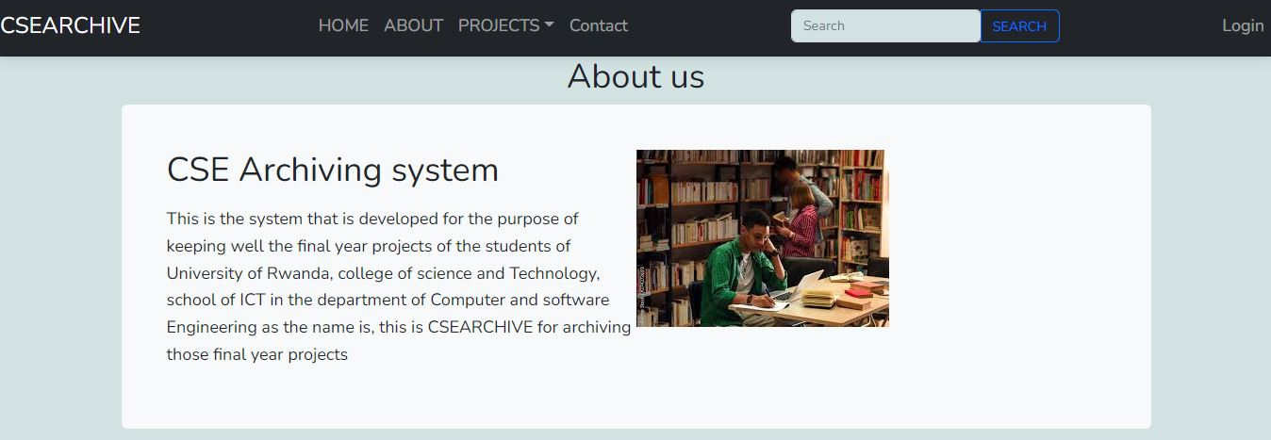

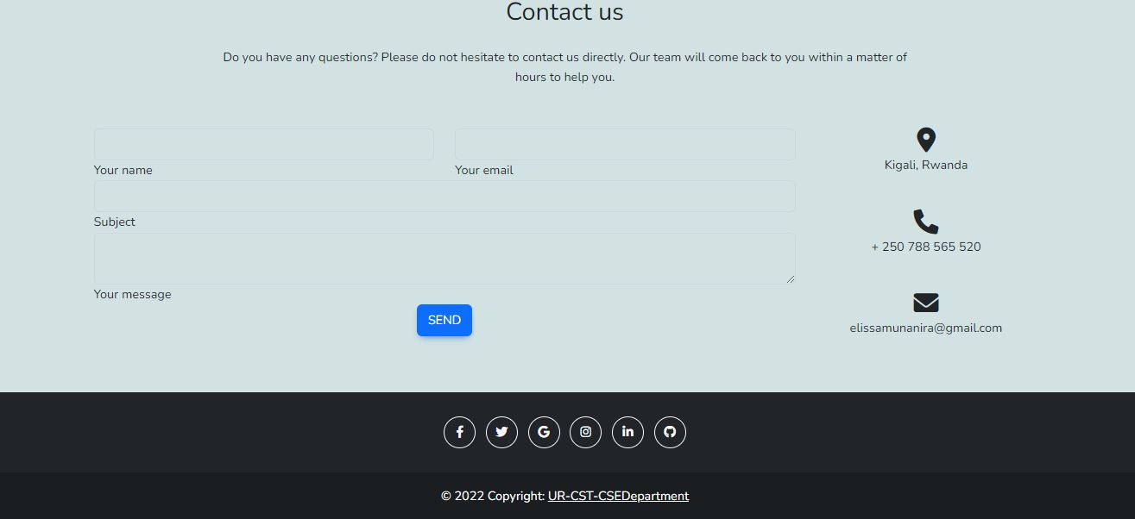

### Contact page

This page contains contact us form to help the user who is interested to talk to us to do so by sending message through filling the form to that form.

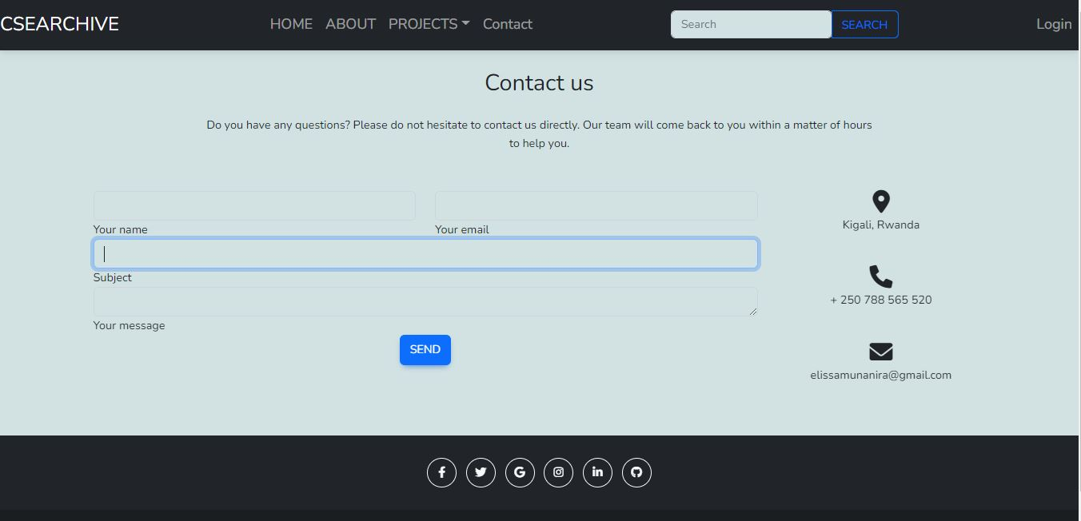



**Projects**

Into the navbar there is link which called projects and it is dropdown link. When the user click on it should get those other related links according to the domain the user is interested in among those which are in the cse department like web, IOT, ML or Adroid based projects and if the user click on one of those projects he/she is going to get all projects that are related on that kind of the domain he/she is requesting.

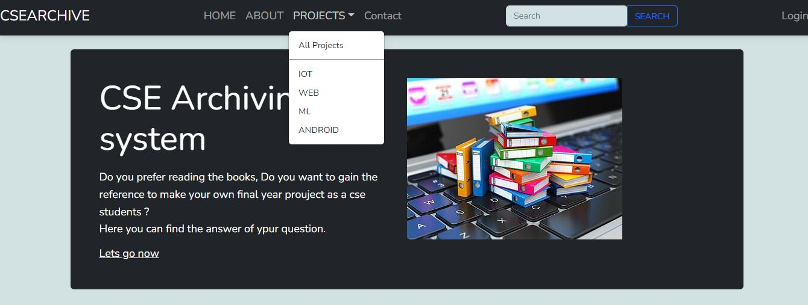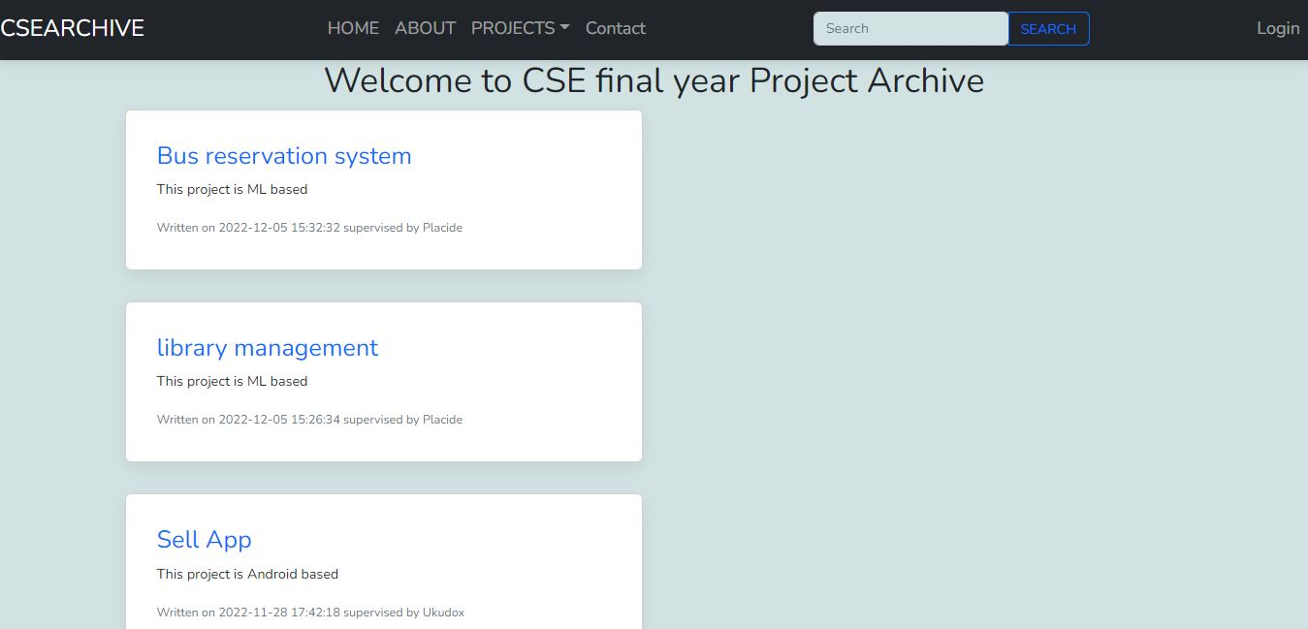

As it is shown on the figure the user should only see the title of projects, its domain , dates it was created at and the supervisor who has supervised that project until the end of it.

The user should get all details when he/ she clicked on the interested project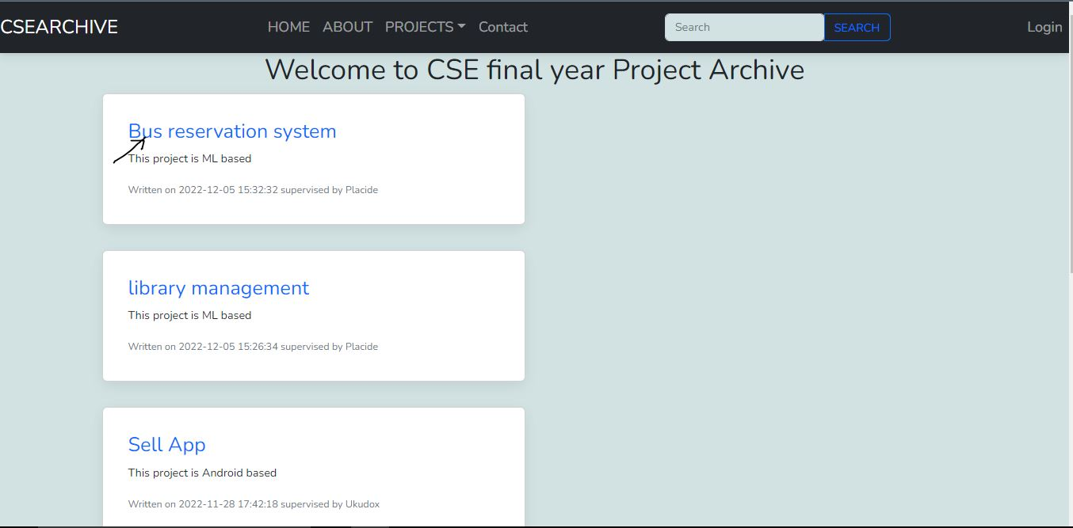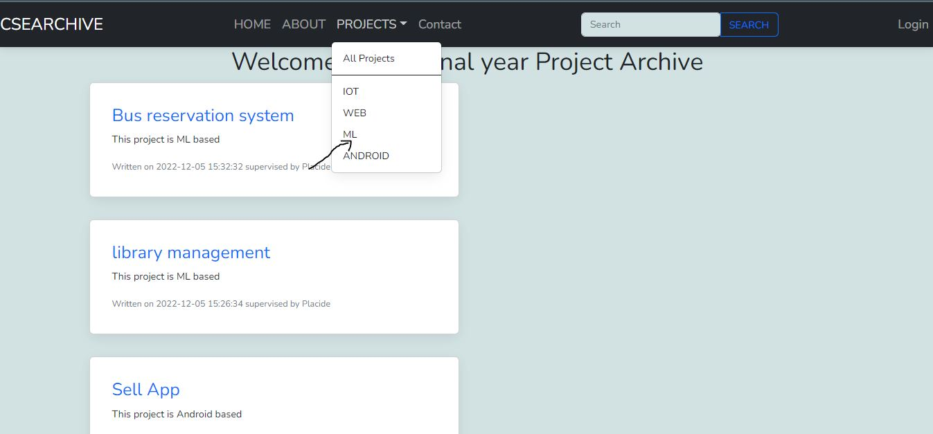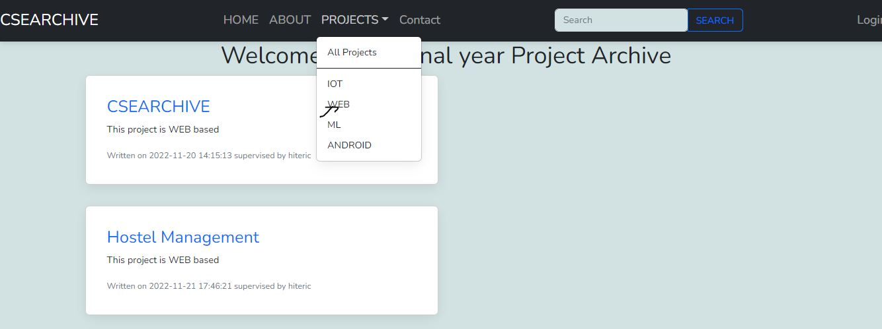This is what the user is going to get get after click on the project all details and he can download the project pdf to get more by clicking on download button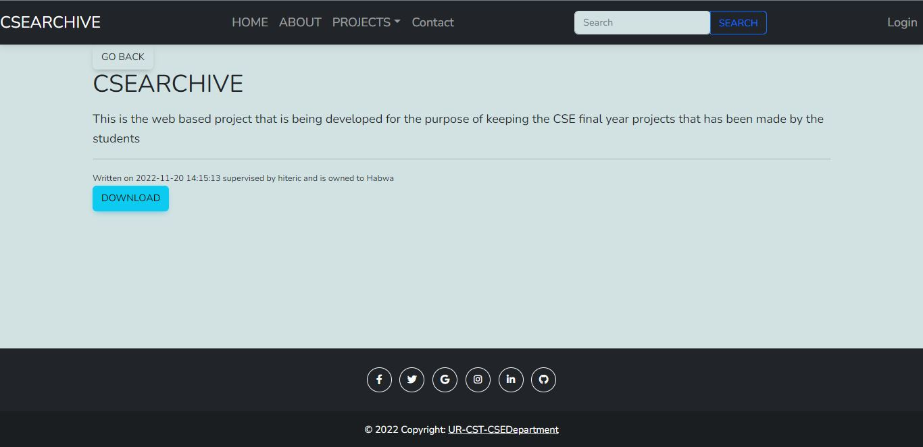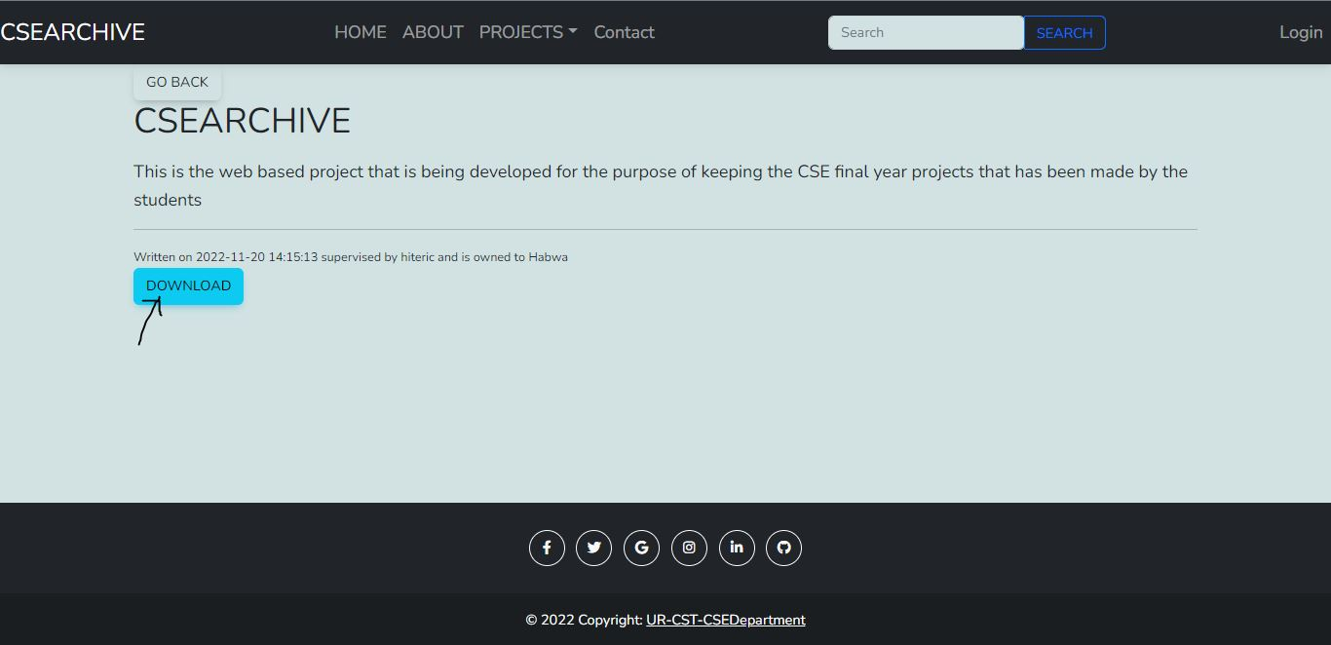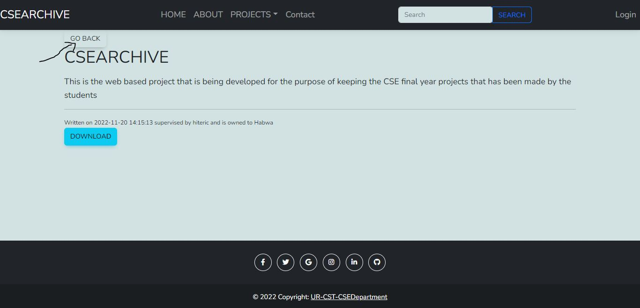

Here is where the Admin can create the new user/lecturers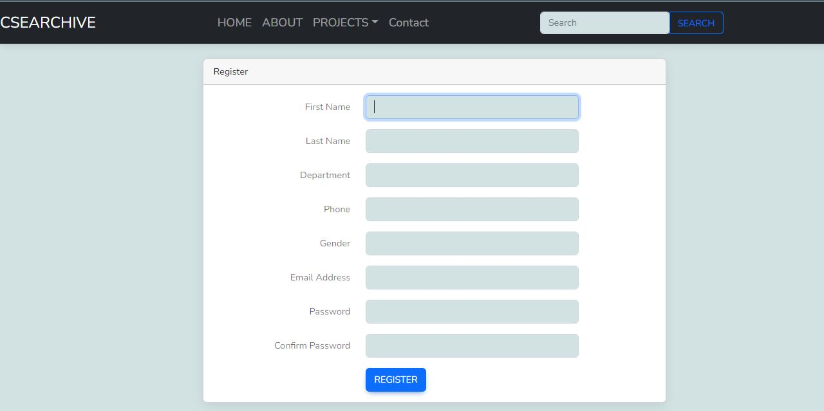

This is the login page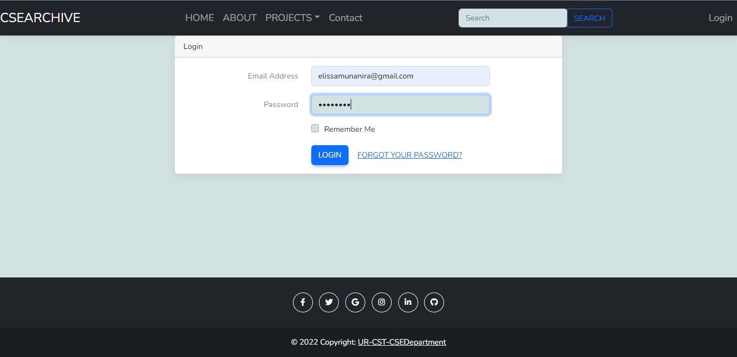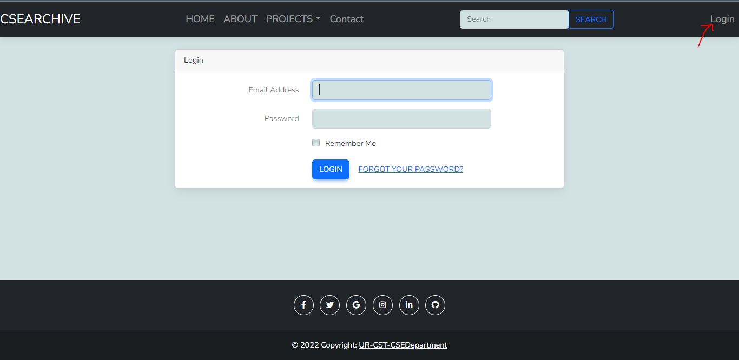

This is the dashboard of each users ( lecturers/supervisors, admin) but the functionalities are different because the supervisor can’t manage the user and there are other admin functionality he/she can’t do except the permission from the admin. Each user should get access to the project he/she has entered to the system.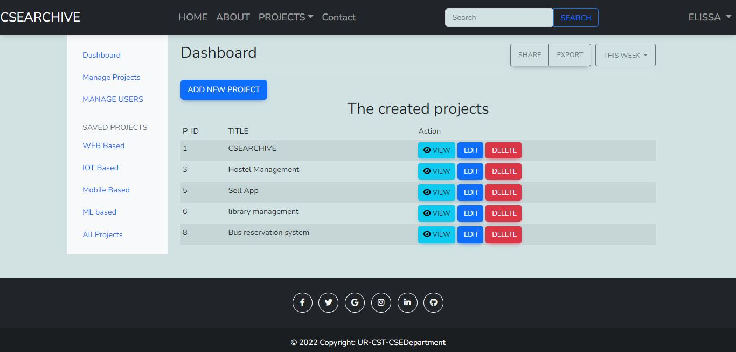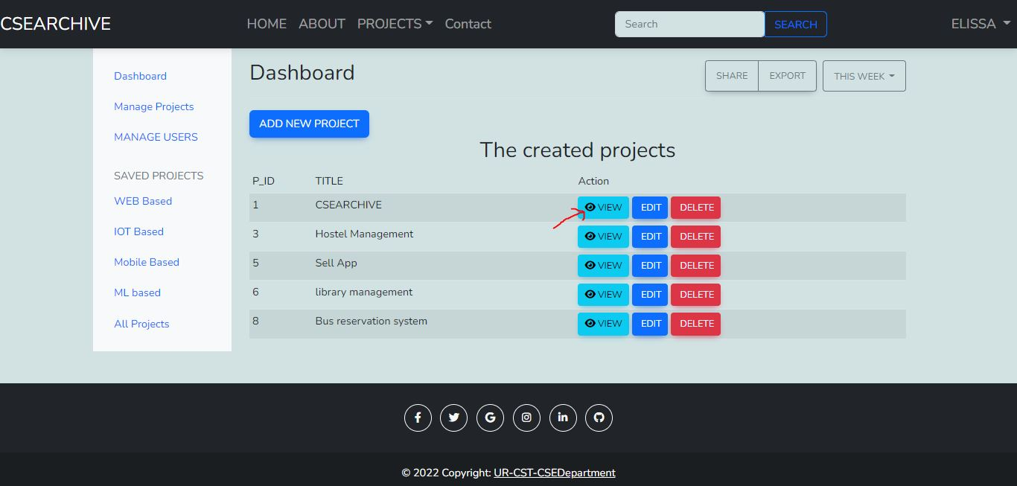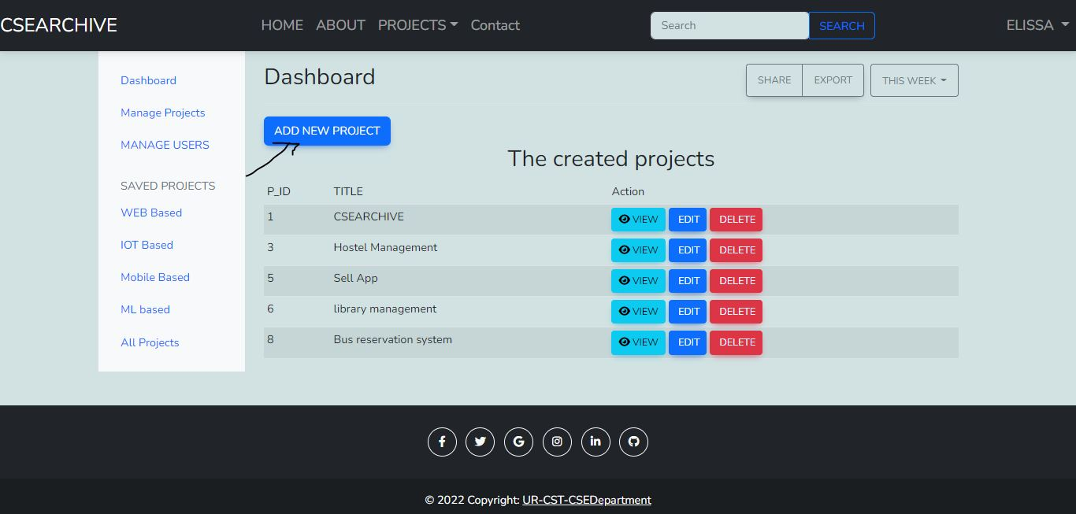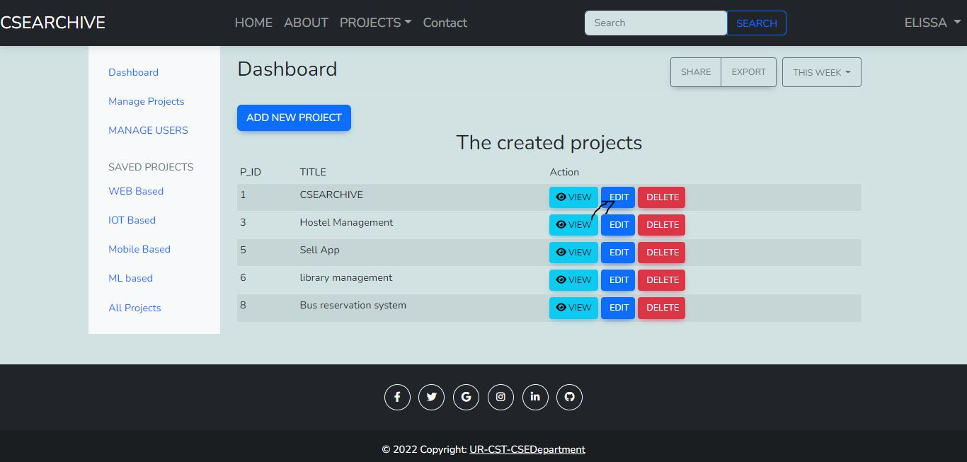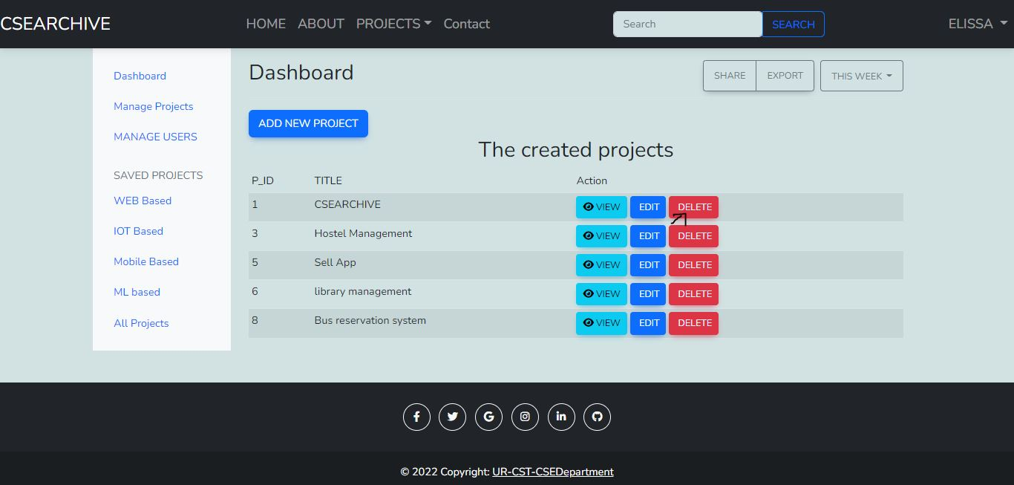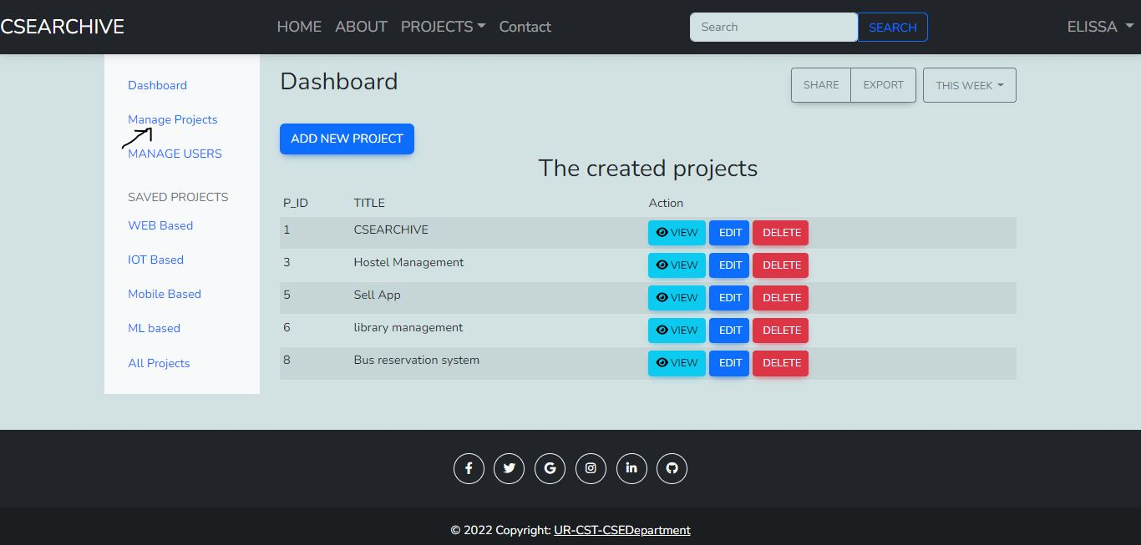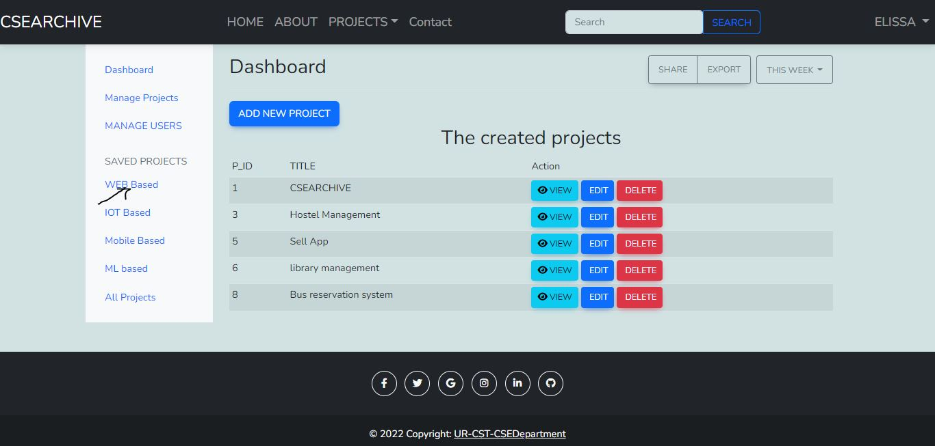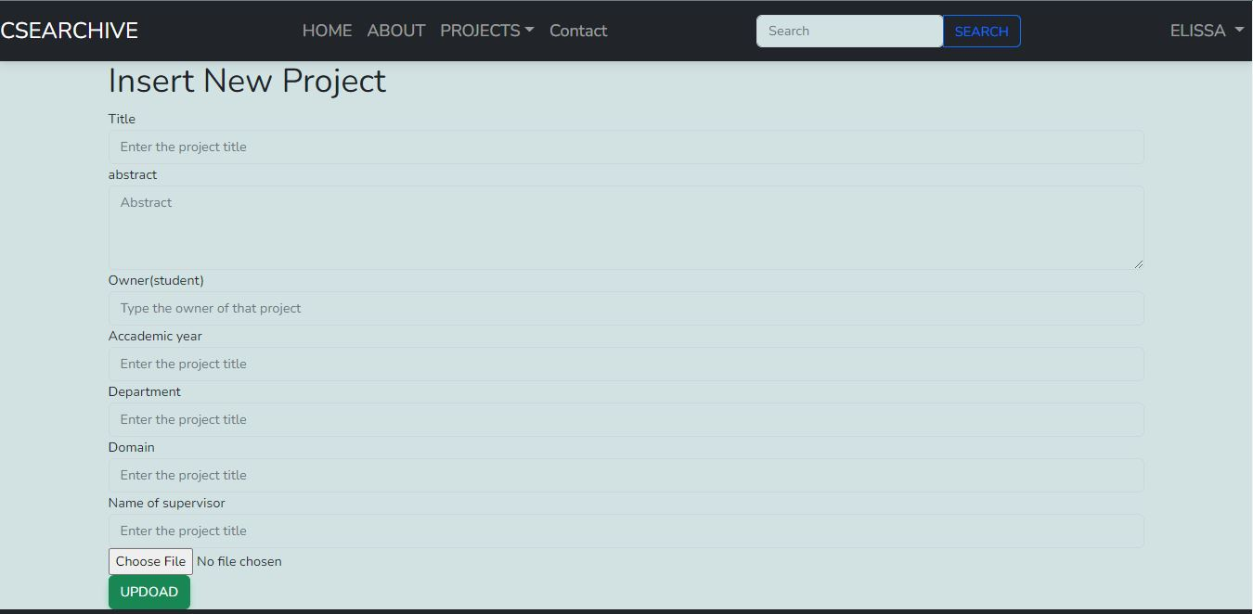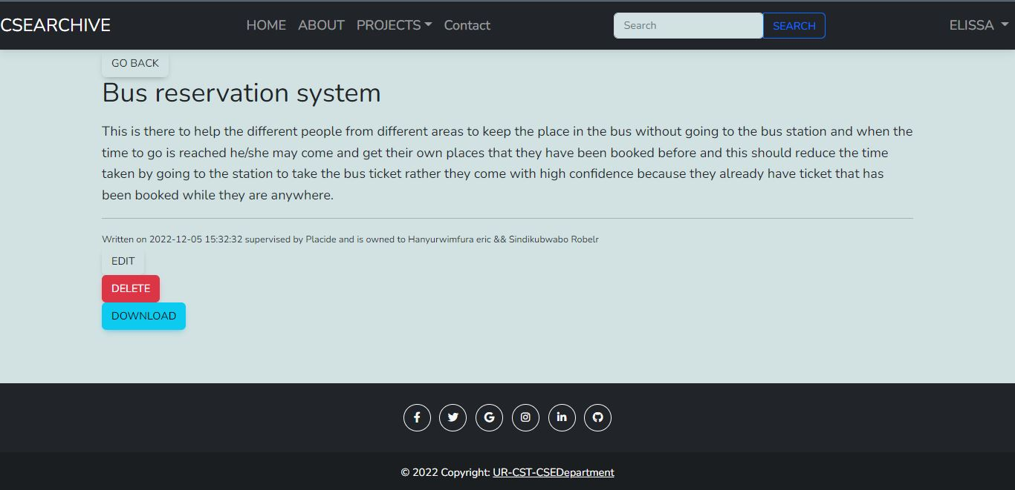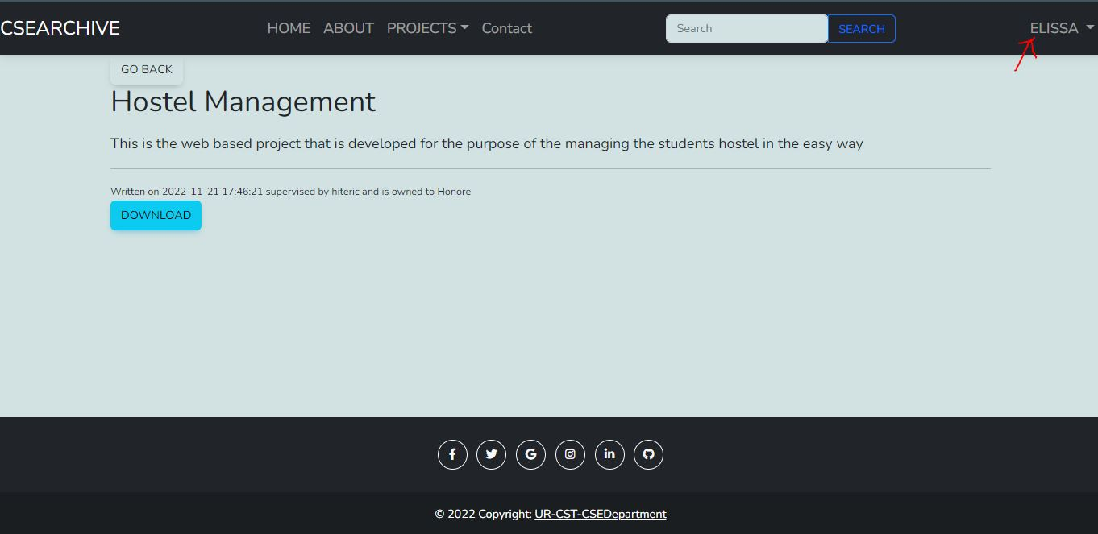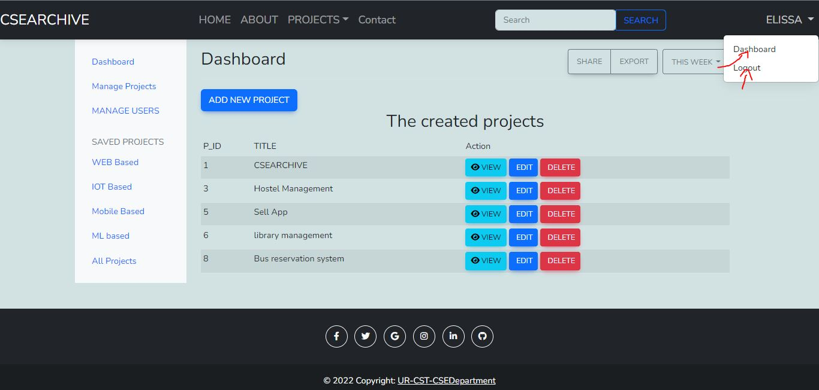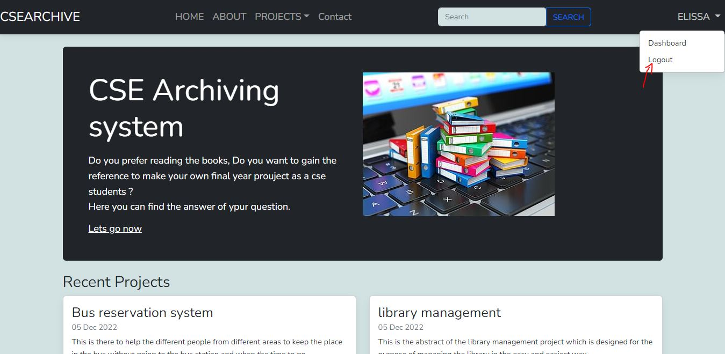

Even if the user has logged in but he is not going to get the access to either edit or delete or update that project because it is not allocated to him( he is not the one who has entered).

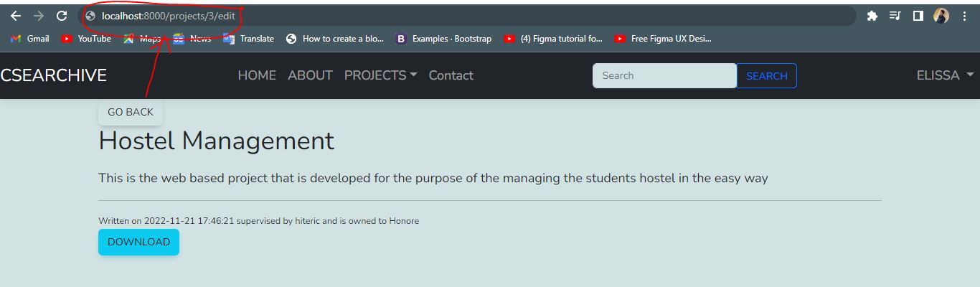



The above is the message that is going to be displayed to the user who want to make one of the CRUD Operation to the project that he/she has not the one that has submit to the system and the message below is the one which is going to be displayed after the user update the project.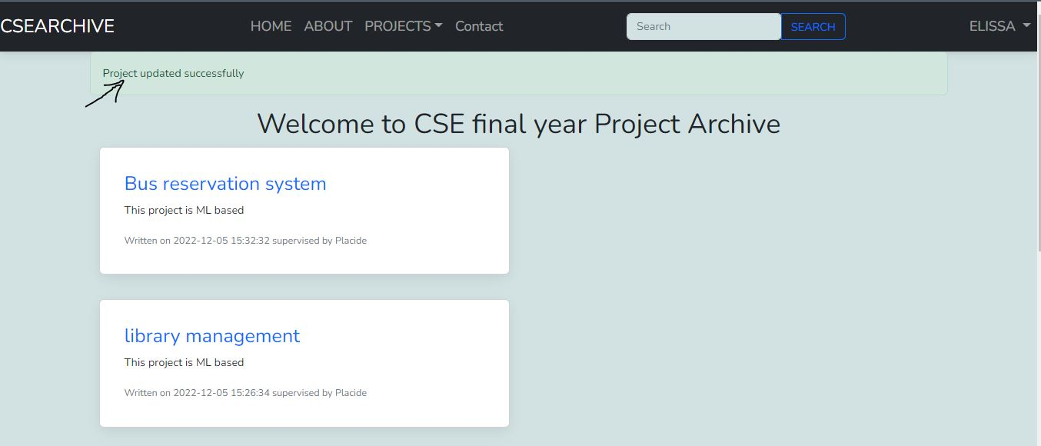

# CHAPTER4. CONCLUSION AND RECOMMENDATION

## CONCLUSION

We can conclude that the system should be used to solve many problems as mentioned in the above sections, where the lack of the final year projects problems is going to reach to the end because by the use of this system the admin/HOD, other lecturers (supervisors) are able to store those finished thesis to this system and the students and other users are there to fetch/ search the final year projects for different purposes like getting the idea on what to deal with by the students.

## RECOMMENDATION

An approach to long-term preservation of digital data and documents is not just a technical and technological issue, but it is also a matter of awareness, attitude, concept, planning and strategy and, finally, politics; not just organizational politics in the context of heritage and information institutions, but the politics of an individual who themself determines, structures and executes their self-archiving activities and practices—from choosing the right format and storage device, through prioritizing organizational and managing tasks, to ensuring secure and successful long-term access to their personal digital collections.

N.B. This is the documentation of the current CFYPAS (CSEARCHIVE ) and it include the 80% of the expected job in order to be finished. The activities that not yet being finished include: making the different dashboard lecturer dashboard and the admin dashboard and other few things to complete as well.

## APPENDIX : https://github.com/elissamunanira/csearchive